Is Health a Blessing? The Macroeconomic Effects of Health Conditions
Mexico as case study

Abstract
Middle-income economies across Latin America are aging at unprecedented speed — Mexico's total fertility rate reached 1.55 in 2024, below the United States at 1.62 — yet their fiscal systems remain unprepared for the health expenditure consequences. Unlike high-income countries with extensive social insurance, economies like Mexico combine low public health spending (626 USD PPP per capita, half the regional average), high out-of-pocket exposure, and a chronic disease burden led by diabetes affecting 16.9% of the population. Existing overlapping generations (OLG) models addressing health and aging are overwhelmingly calibrated to high-income contexts, leaving the middle-income, high-informality environment underexplored. We develop a dynamic stochastic partial equilibrium OLG model in which health status operates as a binary state variable affecting utility, survival probability, labor productivity, and out-of-pocket expenditure, and calibrate it to Mexico using ENOE, CONAPO, CIEP, and OECD data. Three findings stand out: consumption gaps of 40–70% between healthy and unhealthy individuals during working years; a 78% welfare loss for a 30-year-old worker who develops poor health; and income stagnation beginning at age 30 — precisely when health expenditure needs accelerate — departing sharply from standard life-cycle predictions. These results demonstrate that health is not a sectoral expenditure item but a core determinant of macroeconomic stability and intergenerational equity. In economies aging before reaching high-income status, insufficient health investment today depresses productivity, weakens fiscal capacity, and risks crowding out investment in younger cohorts — accelerating the fiscal stress of demographic transition.

Keywords: Macroeconomic equilibrium; Health; Aging; Out-of-pocket expenditures; Overlapping generations; Mexico; Demographic transition; Fiscal sustainability; Middle-income economies; Latin America

Introduction
The global fertility transition has entered a new phase. For the first time in human history, the world's total fertility rate fell below replacement in 2023, and the decline is accelerating most rapidly in middle-income economies. Mexico's total fertility rate reached 1.55 in 2024, falling below the United States at 1.62 — an unprecedented reversal for a country that has not yet attained high-income status. This places Mexico squarely in the "aging before wealth" trap: the demographic pressures traditionally associated with Japan, Germany, or South Korea are arriving decades earlier in the development trajectory, without the fiscal margins those economies built during their high-growth periods. The consequences for health expenditure are immediate. As populations age, health spending pressure intensifies precisely as the contribution base narrows and labor income growth slows. Yet most overlapping generations (OLG) models addressing the macroeconomic effects of health and aging are calibrated to high-income economies with extensive social insurance — not to the institutional and epidemiological context of Latin America.
The health-fiscal nexus in middle-income economies operates through channels that existing literature has not fully captured. In Mexico, per capita public health expenditure stands at 626 USD PPP — half of what Chile, Colombia, Costa Rica, or Panama allocate, and comparable to South Africa (OECD, 2023). This chronic underinvestment coexists with one of the highest chronic disease burdens in the region: 16.9% of Mexico's population lives with diabetes, compared to an OECD average of 7% (OECD, 2023). Diabetes prevalence at this scale is not merely an epidemiological fact — it is a fiscal time bomb interacting with demographic aging. The combination of low public spending and high out-of-pocket exposure means that health shocks transmit directly to household balance sheets, depressing consumption, eroding savings, and increasing dependence on government transfers (CIEP, 2018; Haakenstad et al., 2023). Analyzing these variables in isolation has systematically underestimated the macroeconomic impact of health conditions on national development.
A growing body of OLG literature addresses the macroeconomic consequences of health over the life cycle. De Nardi, French, and Jones (2010) establish medical expenditure risk as a dominant driver of late-life saving behavior. Fioroni (2010) and Dalgaard and Strulik (2014) endogenize health investment and longevity within life-cycle settings. More recent contributions incorporate health transitions into general equilibrium frameworks with demographic dynamics (Franković and Wrzaczek, 2020; Lim, 2020). However, this literature is overwhelmingly calibrated to high-income economies — the United States, Japan, Germany, South Korea — where extensive public health insurance and well-developed social safety nets mediate the household-level impact of health shocks. The middle-income context, characterized by low public health spending, high informality, limited social insurance, and early income stagnation, remains largely unexplored in quantitative macroeconomic modeling.
This paper makes three contributions to the literature. First, methodologically, we develop a dynamic stochastic partial equilibrium OLG model in which health status operates as a binary state variable affecting utility, survival probability, labor productivity, and out-of-pocket expenditure simultaneously — calibrated to Mexico using ENOE labor survey data, CONAPO demographic projections, CIEP fiscal data, and OECD health statistics. Second, empirically, we provide quantitative evidence of consumption gaps, welfare losses, and early-life income stagnation patterns specific to a middle-income Latin American economy, demonstrating that the macroeconomic effects of poor health are not marginal but transformational. Third, from a policy perspective, we show that fiscal stress from demographic aging is not confined to pension systems: health conditions are an underestimated driver of long-run fiscal imbalance, operating through lower tax bases, higher transfer demands, and rising public and private health expenditures simultaneously.

The remainder of the paper is organized as follows. Section 2 presents the partial equilibrium OLG model with health heterogeneity and describes the related literature. Section 3 details the calibration strategy and parametrization for Mexico. Section 4 presents the quantitative results. Section 5 discusses the findings and their implications for fiscal policy and the demographic transition. An appendix documents the evolving burden of disease in Costa Rica, Mexico, and Panama using Global Burden of Disease data, providing the epidemiological foundation for the health dynamics modeled in this paper.

Methods
The overlapping generations model (OLG) of heterogeneous agents is one of the main approaches used to analyze fiscal policy changes. Unlike infinite-horizon representative agent models, this approach allows the incorporation of:
- Life-cycle properties, which are important for determining savings and labor supply decisions.
- Intragenerational household heterogeneity, necessary to analyze the impact of policy changes on income and wealth distribution.
- Intergenerational household heterogeneity, crucial for studying tax schedules and their effects on intergenerational distribution.
A class of OLG models incorporates uncertainty in the form of idiosyncratic household-level shocks, such as labor income or longevity risks, while aggregate variables remain deterministic. These shocks affect agents differently, leading to heterogeneous responses within a cohort. These models are used to calculate the effects of transitioning from one steady state to another and to analyze the welfare implications of reforms for future generations at the expense of transitional ones. The model in this paper belongs to this group of OLG models. It is a dynamic and stochastic incorporating idiosyncratic risks to labor productivity. In contrast to general equilibrium models, partial equilibrium models define factor prices and aggregate macroeconomic variables exogenously, meaning there is no endogenous determination mechanism within the model for these variables (Fehr & Kindermann, 2018). Throughout the paper, ‘macroeconomic’ refers to aggregate life-cycle outcomes generated in a partial-equilibrium setting, rather than a full general-equilibrium framework
Related literature
This paper framework follows a partial-equilibrium life-cycle macro model with overlapping generations. Our conceptualization is related to a growing literature that studies the interaction between health, economic behavior over the life cycle, and demographic change using overlapping-generations (OLG) and life-cycle models. A central insight of this literature is that health is not merely a sectoral outcome or a welfare indicator, but a key state variable shaping consumption, savings, labor supply, and long-run fiscal sustainability. Our analysis builds on this tradition while emphasizing the macroeconomic and fiscal consequences of health conditions in middle-income economies undergoing rapid demographic transition.
A foundational strand of the literature focuses on life-cycle savings behavior under health and medical expenditure risk. A canonical contribution is (De Nardi, French, and Jones 2010), who develop a structural life-cycle overlapping-generations model with idiosyncratic medical expenditure risk to explain why elderly households, particularly in the United States, do not decumulate assets as predicted by standard life-cycle theory. Their framework highlights the role of uncertain and rising medical expenses, differential mortality by income, and social insurance programs that provide a consumption floor.
This work establishes medical expenditure risk as a dominant driver of late-life saving behavior and has become a benchmark for incorporating health risk into life-cycle macro models. While our analysis draws on this tradition, our focus differs in both timing and context. Rather than concentrating on asset decumulation during retirement in high-income economies, we study how health conditions distort income and consumption paths earlier in the life cycle, particularly in environments characterized by limited public health provision and tight fiscal constraints.
Earlier and more stylized contributions also emphasize the joint determination of saving and health spending over the life cycle. (Fioroni 2009) studies a two-period overlapping-generations model in which health spending increases both quality of life and longevity. She shows that saving and health expenditures behave as luxury goods, but with nonlinear income elasticities, generating non-monotonic relationships between income, saving rates, and health spending across countries. Although highly parsimonious, this framework provides early theoretical support for the idea that rising health needs can crowd out saving, particularly in middle-income economies, a mechanism that is further developed in richer stochastic life-cycle models and could have important fiscal implications.
A second strand of the literature endogenizes health investment and longevity within life-cycle settings. For example, (Dalgaard and Strulik 2014) develop a model in which individuals optimally invest in health to slow physiological aging and extend life expectancy. Their framework provides microfoundations for the observed non-linear relationship between income and longevity, commonly known as the Preston Curve, by linking prosperity to health investment decisions and biological aging. Related work by (Kuhn and Feichtinger 2015), and coauthors studies the joint determination of health care, retirement, and consumption in life-cycle models where health affects both mortality and morbidity.
In these models, health influences retirement decisions through the disutility of work and through longevity, which determines the need to accumulate retirement wealth. Conversely, retirement choices affect health by altering the value of survival and morbidity reductions. This literature highlights that health, labor supply, and retirement decisions are deeply intertwined and that health investment can generate inefficiencies, particularly in the presence of annuity markets and moral hazard.
A third strand extends the analysis to broader demographic and policy dimensions. A paper by (Yew and Zhang 2018) study health spending, savings, and fertility in a life-cycle dynastic model with longevity externalities embedded in annuity returns. They show that such externalities can lead to excessive health spending, under-saving, and excessive fertility in laissez-faire equilibria, and they analyze how social security systems and public health subsidies can restore efficiency. While this line of work explicitly models fertility and optimal policy design, our analysis abstracts from endogenous fertility choices in order to focus on how health conditions and medical expenditures distort income and consumption trajectories over the life cycle, with implications for fiscal sustainability under demographic transition.
Recent contributions have also incorporated medical progress and endogenous mortality within general-equilibrium OLG frameworks. For example, (Frankovic and Wrzaczek 2020) study a two-sector overlapping-generations economy in which individuals demand health care to reduce mortality and analyze the effects of major medical innovations that improve the effectiveness of health care. Their results show that general-equilibrium effects substantially dampen the increase in health care utilization following medical innovation, and that higher savings can partially offset the negative impact of population aging on GDP per capita. This work underscores the importance of sectoral reallocation and general-equilibrium feedbacks, while also illustrating why partial-equilibrium life-cycle models remain useful for isolating key behavioral and fiscal mechanisms, particularly in environments with constrained public provision.
Finally, a closely related literature examines the role of public health insurance in shaping savings behavior in aging societies. A paper by (Lim 2020) studies public provision of health insurance in an overlapping-generations model with endogenous health risk calibrated to South Korea. He shows that the expansion of public health insurance can significantly affect aggregate saving behavior by altering precautionary motives in aging economies. This line of work highlights the importance of institutional design in mediating the macroeconomic effects of health risk and complements our analysis by emphasizing the fiscal and savings implications of health financing arrangements.
Taken together, this literature demonstrates that health affects economic outcomes through multiple channels: productivity, survival, medical expenditures, labor supply, and demographic behavior. Our contribution fits within this framework by focusing on the macroeconomic consequences of health conditions in a partial-equilibrium overlapping-generations setting calibrated to a middle-income country context. In contrast to much of the existing work, which is largely motivated by high-income economies with extensive social insurance systems, we emphasize environments characterized by low public health spending, high out-of-pocket exposure, and rapid demographic aging. By doing so, we highlight how health shocks can generate early-life income stagnation, rising indebtedness, and intergenerational trade-offs that pose risks to long-run fiscal sustainability.
Structure of the model
In each period, the economy is populated by overlapping generations indexed by $j=1,…,J$. In every generation j, there are two groups of households: with low and high skill qualifications, indexed by s=1 for the most qualified households and s=2 for less skilled households (both skills have the same parameters unless otherwise indicated).
Survival from one period to the next is assumed to be stochastic and to be the probability that an agent survives from age to age, conditional on living to age. The unconditional probability of surviving to age is given by with $ψ_{j,s}$. Since the number of members of each cohort decreases with respect to age, the age-corresponding cohort size in the period t is:
$$N_{j,s,t}=ψ_{j,s, t}N_{j-1,s,t-1}\text{ with}{ N}_{1,t}=\left(1+n_{p,t}\right)N_{1,s,t-1}$$
The balanced growth trajectory, that is, in which all aggregate variables grow at the same rate, is set at the growth rate of the youngest cohort, which remains constant throughout all periods. These variables added over time are normalized by the size of the youngest cohort living in that period $n_{p,t}=n_{p}t$ for both kinds of skills.
Households
Individuals have preferences over consumption and leisure, and they also pay taxes on consumption and income, as well as a payroll tax to the pension system. The time allocation is assumed to be equal to 1. The household utility function is defined as:
$$c_{j,t}l_{j,t}l_{j,t}tl_{j,t}+l_{j,t}=1$$
$$E\left[\sum_{j=1}^{J}{β^{j-1}}\left(Π_{i=1}^{j}ψ_{i,k}\right)u\left(c_{j,s},1-l_{j,s}\right)\right]$$
where $β$ denotes the temporal discount factor.
Given there are no annuity markets, the return on individual assets corresponds to the net interest rate. In an environment where there is no risk of longevity, agents know with certainty when their life will end. Therefore, they can perfectly plan when they want to consume all their savings. In this model, there is survival uncertainty; agents can die before their maximum lifespan and, consequently, leave an inheritance. Denote the inheritance that an agent receives in the specific period $Jb_{j,t}jt$.
Consumer decision problem
Households maximize the utility function subject to the intertemporal budget constraint.
$$a_{j+1,s}=\left(1+r_{t}^{n}\right)a_{j,s}+w_{t}^{n}h_{j,s}l_{j,s}+b_{j,s}+pen_{j,s}-p_{t}c_{j,s}$$
Where:
- $a_{j,t}$ are the savings-assets of the agent in the period t,
- $w_{t}^{n}=w_{t}\left(1-τ_{t}^{w}-τ_{t}^{p}\right)$ is the net wage rate, which is equal to the market wage minus labor income taxes and the payroll tax to finance the pension system, $w_{t}τ_{t}^{w}τ_{t}^{p}$
- $r_{t}^{n}=r_{t}\left(1-τ_{t}^{r}\right)$ is the net interest rate, which is equal to the market interest rate minus the capital income tax, $r_{t}τ_{t}^{r}$
- $p_{t}=1+τ_{t}^{c}$ It is the consumer price normalized to one plus consumption taxes, $τ_{t}^{c}$
Agent optimization problem
The following expected utility function separable in time is considered (De Nardi, French, & Jones, 2010)
$$E\left[\sum_{j=1}^{J}{β^{j-1}}\left(\prod_{i=2}^{j}{ψ_{i}(m_{i-1})}\right)u_{m}(c_{j})\right]$$

The instantaneous utility is given by:
$$u_{m}\left(c_{j}\right)=δ(m_{j})\frac{{c_{j}}^{1-\frac{1}{γ}}}{1-\frac{1}{γ}}$$
The indicator variable $m_{j} ϵ \left[0,1\right]$ denotes the state of health of an agent, may be good
$(m_{j}=0)$or bad $\left(m_{j}=1\right)$. Where $δ ϵ \left] -1 ; 1 \right[$ determines how health status affects consumption. Furthermore, the state of health at the previous age affects the probability of survival such that $ψ_{j}(m_{j-1}=1) = χ ∙ ψ_{j}(m_{j-1} = 0) with χ < 1.$
In the baseline specification without health shocks, the budget constraint coincides with that of the reference model. The transition of probabilities from one health state to another $π_{j,m,m^{+}} ϵ \left[0;1\right]$ depends on age j and income group $θ$. We assume that the probabilities of having a bad health condition in the future when the current health condition is good increases linearly from ${pg}_{1}$ to ${pg}_{J}$ . The state vector changes to $z=(j,a,θ,m,η)$.

Mathematical Formulation of the Model
This section provides a detailed mathematical specification of the household optimization problem, building on the OLG framework presented above. The model incorporates three key extensions: (i) skill-dependent health transitions, (ii) health-dependent labor productivity, and (iii) out of pocket health costs with a government-provided consumption floor.

Household Problem and State Space
Household maximize expected lifetime utility subject to health uncertainty, income shocks, and medical expenditure risk. The household optimization problem is:
$$E_{0}\left[\sum_{j=1}^{J}{β^{j-1}}\left(\prod_{i=2}^{j}{ψ_{i}\left(m_{i-1}\right)}\right)u_{mj}(c_{j})\right]$$
where β is the discount factor, ψᵢ(mᵢ₋₁) is the survival probability conditional on previous health status, and uₘⱼ(cⱼ) is period utility that depends on health status. The utility function takes the form:
$u_{m}\left(c_{j}\right)=δ(m_{j})\frac{c_{j}^{1-\frac{1}{γ}}}{1-\frac{1}{γ}}$ , $δ\left(m_{j}\right)=1-δ·m_{j}$
with δ(m) = 1 - δ·m capturing the utility penalty from poor health (δ = 0.1 implies 10% utility reduction when sick).
The state space at age j is six-dimensional: zⱼ = (j, aⱼ, θ, mⱼ, ηⱼ, ζⱼ), where:
- j: age (cohort index from 1 to J)
- aⱼ: asset holdings (continuous state variable)
- θ: permanent skill level (θ₁ for low-skilled, θ₂ for high-skilled)
- mⱼ: health status (binary: 0 = healthy, 1 = sick)
- ηⱼ: transitory productivity shock following AR(1) process with persistence ρ = 0.985
- ζⱼ: health cost shock drawn i.i.d. from N(0, σ²ζ) with σζ = 0.2
The expansion from the standard five-dimensional state space (j, a, θ, m, η) to include health cost shocks (ζ) allows the model to capture uncertainty in medical expenditures beyond deterministic age patterns.

Budget Constraint with Health Costs
The household faces the following budget constraint in each period:
$$a_{\left(j+1\right)}+hc_{j}+c_{j}=\left(1+r\right)a_{j}+w⋅h_{j}\left(m_{j}\right)+pen_{j}+b_{j}$$
where:
- aⱼ₊₁: asset holdings carried into next period (subject to aⱼ₊₁ ≥ 0)
- hcⱼ: out-of-pocket health expenditures
- cⱼ: consumption
- r: exogenous interest rate
- w: wage rate
- hⱼ(mⱼ): labor productivity (depends on health status, detailed below)
- penⱼ: pension income (for retirees)
- bⱼ: government transfer ensuring consumption floor
Out-of-pocket health costs follow the specification:
$$hcⱼ = kⱼ · exp(ζⱼ)$$
where kⱼ increases linearly with age from k₁ = 0.3 to kⱼ = 0.9, and ζⱼ ~ N(0, 0.04) is a log-normal shock. This formulation captures:
- Rising healthcare needs with age (captured by kⱼ)
- Stochastic variation in medical expenses (captured by exp(ζⱼ))
- Potential for catastrophic health costs (right tail of log-normal distribution)
The government provides transfers to ensure a minimum consumption level:
$$b_{j}=max\left[\underline{c}+hc_{j}-\left(1+r\right)a_{j}-w·h_{j}\left(m_{j}\right)-pen_{j},0\right]$$
with consumption floor c̄ = 0.05. This specification guarantees cⱼ ≥ c̄ for all households, representing Medicaid-type programs and social safety nets.

Skill-Dependent Health Transitions
A critical innovation is that health transition probabilities depend on permanent skill levels, reflecting differential exposure to health risks and access to healthcare.
For LOW-SKILLED workers (θ = θ₁ = -√0.242):
The probability of transitioning from healthy to sick increases linearly with age:
$$pg_{j}^{low}=0.10+\left(0.40-0.10\right)×\left(j-1\right)/\left(J-1\right)$$
At age 1: pg₁ˡᵒʷ = 0.10 (10% chance of becoming sick)
At age J: pgⱼˡᵒʷ = 0.40 (40% chance of becoming sick)
At age 50 (middle age): pg₅₀ˡᵒʷ ≈ 0.21 (21% chance of becoming sick)
The persistence of poor health (probability of remaining sick) is:
$$pb_{j}=0.60+\left(0.90-0.60\right)×\left(j-1\right)/\left(J-1\right)$$
This ranges from 60% at young ages to 90% at old ages, reflecting increasing difficulty of recovery with age.
For HIGH-SKILLED workers (θ = θ₂ = √0.242):
The probability of becoming sick is substantially lower:
$$pg_{j}^{high}=0.00+\left(0.20-0.00\right)×\left(j-1\right)/\left(J-1\right)$$
At age 1: pg₁ʰⁱᵍʰ = 0.00 (essentially no risk of becoming sick when young)
At age J: pgⱼʰⁱᵍʰ = 0.20 (20% chance of becoming sick when old)
At age 50: pg₅₀ʰⁱᵍʰ ≈ 0.08 (8% chance of becoming sick)
The persistence of poor health is the same as for low-skilled workers (pbⱼʰⁱᵍʰ = pbⱼˡᵒʷ), reflecting that once sick, recovery rates are similar across skill groups—the key difference is in becoming sick in the first place.
Economic Interpretation:
High-skilled workers at age 50 are approximately 2.6 times less likely to become sick (8% vs. 21%). Over a lifetime, this creates substantial cumulative health advantages. The model captures three empirical regularities: (1) better-educated workers have better health outcomes, (2) health disparities widen with age, and (3) socioeconomic status affects disease incidence more than disease progression.

Health-Dependent Labor Productivity
Labor productivity depends on health status through skill-specific penalty parameters. For working-age households (j < JR), productivity is:
$$h_{j}\left(m_{j}\right)=e_{j}·exp\left(θ+η_{j}-ϱ\left(θ\right)·m_{j}\right)$$
This can be decomposed into four components:
- eⱼ: deterministic age-efficiency profile (hump-shaped over life cycle)
- exp(θ): permanent skill component (θ₁ for low-skilled, θ₂ for high-skilled)
- exp(ηⱼ): transitory shock following AR(1) process
- exp(-ϱ(θ)·mⱼ): health-dependent penalty
The health penalty parameters are:
- ϱ₁ = 0.20 for low-skilled workers
- ϱ₂ = 0.10 for high-skilled workers
When healthy (m = 0): exp(-ϱ·0) = 1 (no penalty)
When sick (m = 1):
- Low-skilled: exp(-0.20) ≈ 0.819 (19% productivity loss)
- High-skilled: exp(-0.10) ≈ 0.905 (9.5% productivity loss)
Economic Rationale:
The larger penalty for low-skilled workers reflects that:
- Physically demanding jobs are more affected by poor health
- Low-skilled workers have less workplace accommodation for health limitations
- Professional jobs (high-skilled) allow more flexibility to work around health issues
- Education may provide knowledge to better manage health conditions
This specification implies that poor health creates both a level effect (lower productivity) and a distributive effect (larger impact on low-skilled workers), reinforcing income inequality.

Government Transfer and Consumption Floor
The consumption floor is implemented through means-tested transfers:
$$b_{j}=max\left[\underline{c}+hc_{j}-\left(1+r\right)a_{j}-w·h_{j}\left(m_{j}\right)-pen_{j},0\right]$$

This formulation has several important features:
- Coverage of health costs: The transfer covers both the consumption shortfall (relative to c̄) AND the health costs hcⱼ. A household with zero resources receives c̄ in consumption and has their health costs fully covered.
- Asset test: The transfer decreases with asset holdings (captured by (1+r)aⱼ term). Wealthier households receive smaller transfers.
- Income test: The transfer decreases with labor income w·hⱼ(mⱼ) and pension income penⱼ. Higher earners receive smaller transfers.
- Automatic stabilization: When a household experiences a health shock (high hcⱼ), the transfer automatically increases to prevent consumption from falling below c̄.
Economic Effects:
- Insurance: Provides insurance against catastrophic health costs, preventing destitution
- Moral hazard: Reduces incentives for precautionary savings (households know they won't fall below c̄)
- Redistribution: Disproportionately benefits low-skilled workers who face higher health risks
- Fiscal cost: Government transfers increase with population aging and health deterioration
The consumption floor of c̄ = 0.05 represents approximately 5% of average income, consistent with empirical estimates of minimum consumption in developed economies.

The Bellman Equation and Optimization
The household optimization problem is solved recursively using dynamic programming. At each age j, the household chooses savings aⱼ₊₁ to maximize lifetime utility:
$$V_{j}\left(a_{j},θ,m_{j},η_{j},ζ_{j}\right)=max_{\left(a_{\left(j+1\right)}≥0\right)}\left[u_{\left(m_{j}\right)}\left(c_{j}\right)+βψ_{\left(j+1\right)}\left(m_{j}\right)E_{j}\left[V_{\left(j+1\right)}\left(a_{\left(j+1\right)},θ,m_{\left(j+1\right)},η_{\left(j+1\right)},ζ_{\left(j+1\right)}\right)\right]\right]$$

where:
- Vⱼ is the value function (maximum attainable utility from age j onward)
- uₘⱼ(cⱼ) is current period utility
- β is the discount factor (β = 0.98)
- ψⱼ₊₁(mⱼ) is the survival probability (depends on current health status)
- Eⱼ[·] denotes expectation conditional on current state
The expectation operator integrates over three sources of future uncertainty:
Health transitions: mⱼ₊₁ ∈ {0,1} with probabilities πⱼ(mⱼ₊₁|mⱼ,θ)
Income shocks: ηⱼ₊₁ follows AR(1) process with ρ = 0.985, discretized into 7 grid points
Health cost shocks: ζⱼ₊₁ ~ N(0, 0.04) i.i.d., discretized into 5 grid points
With discretization, there are 2 (health) × 7 (income) × 5 (health costs) = 70 possible realizations of next period's state at each decision node.

First Order Condition (Euler Equation)
The interior solution (aⱼ₊₁ > 0) satisfies the Euler equation:
$$δ\left(m_{j}\right)c_{j}^{\left(-1/γ\right)}=βψ_{\left(j+1\right)}\left(m_{j}\right)\left(1+r\right)E_{j}\left[δ\left(m_{\left(j+1\right)}\right)c_{\left(j+1\right)}^{\left(-1/γ\right)}\right]$$
This equation equates:
- Left side: marginal utility of current consumption
- Right side: expected discounted marginal utility of saving (future consumption)
Numerical implementation: For each state (aⱼ, θ, mⱼ, ηⱼ, ζⱼ), we use root-finding (bisection or Newton's method) to find aⱼ₊₁ that satisfies: cⱼ(aⱼ₊₁) - RHSⱼ(aⱼ₊₁) = 0, where cⱼ(aⱼ₊₁) comes from the budget constraint and RHSⱼ is the right-hand side of the Euler equation.
Corner solution (aⱼ₊₁ = 0):
If the Euler equation implies aⱼ₊₁ < 0, the borrowing constraint binds. We set aⱼ₊₁ = 0 and consume all available resources (after paying health costs): cⱼ = (1+r)aⱼ + w·hⱼ(mⱼ) + penⱼ + bⱼ - hcⱼ

Numerical Solution Algorithm
The model is solved using backward induction for policy functions followed by forward simulation for the distribution.

Backward Iteration (Solving for Policy Functions)
Step 1: Terminal period (j = J)
- Set aJ+1 = 0 (no bequests)
- Consumption: cJ = (1+r)aJ + penJ + bJ - hcJ
- Value: VJ = uₘJ(cJ)
Step 2: For each age j = J-1, J-2, ..., 1:
Define grids: Asset grid {a₁, ..., aₙₐ} (typically 50-100 points), Income shock grid (7 points), Health cost grid (5 points)
For each grid point (aᵢ, θₛ, mₖ, ηₗ, ζₘ):
• Solve Euler equation to find optimal savings a*ⱼ₊₁ (if a*ⱼ₊₁ < 0, set a*ⱼ₊₁ = 0)
• Compute optimal consumption: c*ⱼ = (1+r)aᵢ + w·hⱼ(mₖ) + penⱼ + bⱼ - hcⱼ(ζₘ) - a*ⱼ₊₁
• Compute continuation value by interpolating Vⱼ₊₁
• Compute current value: Vⱼ = uₘₖ(c*ⱼ) + βψⱼ₊₁(mₖ) · V^cont
• Store policy functions: a*ⱼ, c*ⱼ, and Vⱼ
Step 3: Repeat for all ages until reaching j = 1
This produces policy functions {a*ⱼ, c*ⱼ, Vⱼ} for all j and all possible states.

Forward Simulation (Computing the Distribution)
Once policy functions are computed, simulate the cross-sectional distribution of households:
Initialize at j = 1: All households start with zero assets (a₁ = 0). Distribute initial population across (θ, m₁, η₁, ζ₁): 50% low-skilled, 50% high-skilled; initial health determined by pg₁(θ); shocks drawn from stationary distributions.

For each age j = 2, 3, ..., J:
• For each household type at j-1: Look up optimal savings a*ⱼ from policy function
• Distribute mass to age j states weighted by transition probabilities: μⱼ(a*ⱼ, θ, mⱼ, ηⱼ, ζⱼ) += μⱼ₋₁ × πⱼ(mⱼ|mⱼ₋₁,θ) × πη(ηⱼ|ηⱼ₋₁) × πζ(ζⱼ)
• Account for mortality: μⱼ = ψⱼ(mⱼ₋₁) × μⱼ
• Normalize distribution to maintain constant cohort size
Step 3: Aggregate to compute cohort averages:
- Average consumption by skill and health: C̄ⱼ(θ,m)
- Average assets by skill and health: Āⱼ(θ,m)
- Average income by skill and health: Ȳⱼ(θ,m)
- Fraction receiving transfers by skill and health
- Wealth inequality measures (Gini coefficient, percentile ratios)

Key Parameters and Calibration Strategy
The model parameters are calibrated using a combination of: (1) Direct empirical evidence from Mexico, (2) Standard values from the macroeconomics literature, and (3) Calibration to match aggregate moments.
Parameter | Value | Description/Justification
Γ | 0.5 | Intertemporal elasticity of substitution (mid-range of macro estimates)
Β | 0.98 | Annual discount factor (2% time preference rate)
Δ | 0.1 | Utility penalty from poor health (10% reduction when sick)
ϱ₁ | 0.2 | Low-skilled productivity penalty (19% income loss when sick)
ϱ₂ | 0.1 | High-skilled productivity penalty (9.5% income loss when sick)
Σζ | 0.2 | Volatility of health cost shocks
k₁, kJ | 0.3, 0.9 | Health cost age profile (tripling from young to old)
c̄ | 0.05 | Consumption floor (5% of average income)
pgˡᵒʷ | [0.1, 0.4] | Low-skilled probability of becoming sick (increases with age)
pgʰⁱᵍʰ | [0.0, 0.2] | High-skilled probability of becoming sick (50% lower)
Pb | [0.6, 0.9] | Persistence of poor health (same for both skills)
Ρ | 0.985 | AR(1) persistence of transitory income shocks
Σε | 0.022 | Innovation variance of transitory shocks

These parameters jointly determine: (1) the strength of precautionary savings motives, (2) the magnitude of health-related inequality, (3) the value of the social safety net, and (4) the life-cycle profiles of consumption, assets, and welfare.

Key Economic Mechanisms

Cumulative Health Advantage
High-skilled workers enjoy better health outcomes through multiple channels:
- Lower probability of becoming sick at every age (skill-dependent transitions)
- Higher income enables better nutrition, housing, and healthcare access
- Less physically demanding jobs reduce wear-and-tear on the body
- Better health → higher productivity → more wealth → better health (reinforcing cycle)

Health-Income Poverty Trap
Low-skilled workers face a poverty trap mechanism:
- Poor health reduces productivity by 19% (vs. 9.5% for high-skilled)
- Lower income limits ability to invest in health
- Higher health costs relative to income (same absolute costs, lower income)
- More likely to hit consumption floor and require government transfers
- Reduced ability to save for future health shocks

Role of Government Transfers
The consumption floor provides insurance against catastrophic health costs:
- Prevents extreme poverty when health shocks occur
- Reduces precautionary savings (moral hazard effect)
- More valuable for low-skilled workers (higher probability of use)
- Trade-off between protection and work incentives
- Fiscal cost increases with population aging and health deterioration
Dynamic optimization problem
The dynamic optimization problem of an individual in the presence of different health conditions is given by:
$$V(z)=\max_{c,a^{+}}{u_{m}(c)+βψ_{j+1}(m)E\left[V(z^{+})|m,η\right]}$$
s.a. $a^{+}=(1+r)a+wh+pen-c, a^{+}≥0,$
$η^{+}=ρη+ϵ^{+} con$ $ϵ^{+}\sim N(0,σ_{ϵ}^{2})$
$$π_{j,m,m^{+}}=Pr(m_{j+1}=m^{+}|m_{j}=m) con m.m^{+} ϵ\left\{0,1\right\},$$
With the definition of instantaneous utility function $u_{m}(c)$ previously defined, and its respective Lagrangian that leads to the following first order condition:
$$c={\left(βψ_{j+1}\left(m\right)\left(1+r\right)δ{\left(m\right)}^{-1}∙E\left[δ(m^{+})c{\left(z^{+}\right)}^{-\frac{1}{γ}}|m,η\right]\right)}^{-γ}$$
Where we use the notation $z^{+}=(j,a^{+},θ,m^{+},η^{+})$.
In addition to the current productivity shock $η$, The expected marginal utility of future consumption also depends on the health condition in the current state, m.
In each period, the transition of health states is determined by the age-dependent transition matrix $π_{j,m,m^{+}.}$ The immediate utility of individuals in poor health is scaled with the parameter $δ(m)$ and by the probability of survival subject to a discount factor $χ$. Note that poor health introduces a shock to the probability of survival as long as that condition persists. That shock disappears if there is a transition to good health condition.
From this definition, we extend the model with the following changes:
We assume that the transition probabilities depend on the income group by setting $\left[{pg}_{1};{pg}_{J}\right] = \left[0.0;0.2\right]$for the highest income group.
Furthermore, we allow productivity to be affected by health status if $j < j_{r}$;
$$h_{j}(m_{j})=e_{j}∙exp\left[θ+η_{j}-ϑ_{θ}m_{j}\right]$$
Where $ϑ_{1}=0.2 and ϑ_{2}=0.1$
Finally, we assume that a state of poor health generates out-of-pocket spending, which depends on a deterministic age profile $k_{j}$ and from a stochastic term $ζ_{j}$ normally distributed:
$hc_{j}=k_{j}∙expζ_{j}$ $with ζ_{j}\sim N(0,σ_{ζ}^{2})$
Then, households maximize expected utility subject to (periodic) budget constraints.
$$a_{j+1}+{hc}_{j}+c_{j}=(1+r)a_{j}+{wh}_{j}(m_{j})+{pen}_{j}+b_{j}$$
And to the non-negativity constraint of savings $a_{j+1}≥$ 0. The right side of the equation includes government transfers $b_{j}$, that provide minimum consumption (floor, $\underline{c}$), i.e.,
$$b_{j}=max\left[\underline{c}+hc_{j}-(1+r)a_{j}-wh_{j}(m_{j})-{pen}_{j};0\right]$$
The state vector now increases to $z=(j,a,θ,m,η,ζ)$.
The implementation is numerical with linear and deterministic increases in costs.
$\left[k_{1;}k_{J}\right] = \left[0.3,0.9\right],$ a variance of $σ_{ζ}^{2}=0.2$, and minimal consumption $\underline{c}= 0.05$.

Model parametrization for Mexico
Firstly, for the numerical implementation of the transition probability based on skills between health states, good and bad, a new dimension is added to the transition matrix. Along this additional dimension, we can assign different probabilities of transitioning from a good to a bad health state for each skill group.
Considering that health status depends on the skill group, we begin by computing the averages per cohort throughout the life cycle, after conditioning on both the skill group and the health status of the individuals. Similarly, we then take this cohort-conditional average to compute non-conditional averages and cohort averages that are conditional on health status or skill group, respectively.
Secondly, the numerical implementation of labor productivity based on health condition is very similar to the transition probabilities based on the skill group between different health states. The program is initialized with a new arrangement that corresponds to $ρ$ qthat takes the effect of a shock in health status on productivity, depending on their skill group, and multiplies it by the productivity in the human capital $h_{j}$ of each individual.
In this way, the negative impact of health status on labor productivity implies an effect on income. Household income, discounted over a lifetime, is lower as a result of lower asset accumulation and a lower lifetime consumption pattern. So that the effect on productivity depends on the level of skills, a $ϑ_{θ}$ greater for the less qualified group than for the group of the most qualified, this leads us to a divergence in the future in the accumulation of assets and in consumption patterns conditional on the state of health.
Finally, to incorporate stochastic out-of-pocket expenditures in individuals in poor health, the normal distribution is discretized for the stochastic component $ζ$ and we define current out-of-pocket expenses. The additional state variable $ζ$ results in an additional loop that interacts with the discretized space. In each state where a poor health condition exists current out-of-pocket expenses. The additional state variable $(m = 1)$, the individual is exposed to out-of-pocket expenses $hc$.
Table 1. Exogenous parameters (Y) calibrated (C) and objective (T).
Parameter | Description | Y | C | T | Description
$$TT$$ | Number of transition periods. Each period is equivalent to 1 year in real life. | X |  |  | Defined by numerical criteria.
$$JJ$$ | Number of years a household has lived. Households begin their economic life at age 20 (). They live up to 100 years ().j=JJ=80 | X |  |  | Defined by Fehr y Kindermann (2018).
$$JR$$ | Mandatory retirement age. Households retire at age 65  ()$j_{r}=45$ | X |  |  | Defined by Fehr y Kindermann (2018).
$$γ$$ | Relative risk aversion coefficient (reciprocal of  elasticity of intertemporal substitution) |  | X |  | The parameter was calibrated to obtain the results closest to the observed values ​​of the Consumption and Investment ratios with respect to GDP.
$$β$$ | Temporary discount factor. |  | X |  | Calibrated by Fehr y Kindermann (2018).
$$σ_{θ}^{2}$$ | Variance of the fixed effect on productivity. $θ$ |  | X |  | Calibrated by Fehr y Kindermann (2018).
$$σ_{ϵ}^{2}$$ | Variance of the autoregressive component.$η$ |  | X |  | Calibrated by Fehr y Kindermann (2018).
$$κ$$ | Replacement rate of the pension system. | X |  |  | OECD-Pension Indicators-Contributions were consulted
$$ψ_{j}$$ | Survival rates by age cohort. |  | X |  | Defined by Fehr y Kindermann (2018).  For Mexico, the rates are adjusted according to the data from the life tables of the Public Health Intelligence Unit  (SSa, INSP, UISP, 2019)
$$e_{j}$$ | Labor income efficiency profile by age cohort. | X |  |  | Defined by Fehr y Kindermann (2018).  For Mexico, the income profile is adjusted with the data from the ENOE (INEGI, 2015).
R | Interest rate | X |  |  | Defined by Fehr y Kindermann (2018).
W | Wage | X |  |  | Defined by Fehr y Kindermann (2018).
$$Δ$$ | Determines how health status affects the utility of consumption | X |  |  | Defined by Fehr y Kindermann (2018).
$$Χ$$ | Discount factor | X |  |  | Defined by Fehr y Kindermann (2018).
$$c_floor$$ | Floor consumption | X |  |  | Defined by Fehr y Kindermann (2018).
$$σ_{z}$$ | Stochastic shock variance | X |  |  | Defined by Fehr y Kindermann (2018).

Table 2. Value of the parameters.
Description | Parameter | México
Utility function
Coefficient of relative risk aversion (reciprocal of the elasticity of intertemporal substitution) | $$γ$$ | 0.5
Time discount factor | $$β$$ | 0.98
Risk in labor productivity
Autoregressive component of the productivity shock | $$ρ$$ | 0.98
Variance of the fixed effect on productivity.$θ$ | $$σ_{θ}^{2}$$ | 0.242
Variance of the autoregressive component.$η$ | $$σ_{ϵ}^{2}$$ | 0.022
Pension system
Replacement rate of the pension system | $$κ$$ | 0.5
Factor prices
Interest rate | r
Wage | w
Health risk factors
Determinant of health status in utility | $$δ$$
Discount factor | $$χ$$
Floor consumption | c_floor | 0.05
Variance of the stochastic shock | $$σ_{z}$$ | 0.2

Results
The reference model corresponds to the calibrated life-cycle model without health heterogeneity or stochastic medical expenditures, following Fehr and Kindermann (2018). The results are presented in Table 3. The first figure corresponds to the partial model defined by the reference literature, the second presents the results with the parameters defined for Mexico, first for consumption, then for income and, finally, for the proportion of out-of-pocket spending for health services.
Firstly, it is observed that, although the literature speaks of consumption more concentrated towards ages of 60 and over, in Mexico, consumption is higher in the population under 60 years of age. Furthermore, the group with higher skills has a higher level of consumption than the group with lower skills as a result of lower income generated by their health condition. It is observed that, at average levels, the greatest gap occurs in consumption levels due to poor health conditions.
The results coincide with the intuition that tells us that, at a certain level of skills, individuals with a good health condition consume more than individuals with a poor health condition. Furthermore, the proportion of individuals with poor health is higher in the less qualified group than in the more skilled group.
In Mexico the income practically stagnates after the age of 30. Unlike the reference model, which continues to increase from 30 to 50 years. This is due to a selection effect, in which an individual in poor health is more likely to also have a lower income, while an individual in good health has higher productivity.
Thirdly, in terms of the proportion of income that is borrowed as a result of greater spending due to health conditions. In the reference model, this fraction increases around age 60, due to health needs, since, by definition of the model, there is a precautionary effect in which savings are made to ensure out-of-pocket expenses in future years. However, in Mexico, this begins to increase from the age of 30. Government transfers and subsidies would have to increase to ensure that individuals do not end up with a negative level of consumption due to out-of-pocket health expenditures that exceed their level of income and asset accumulation.

Figure 3. Consumption, income and the ratio of health expenditures to income.
Reference Model | Mexico
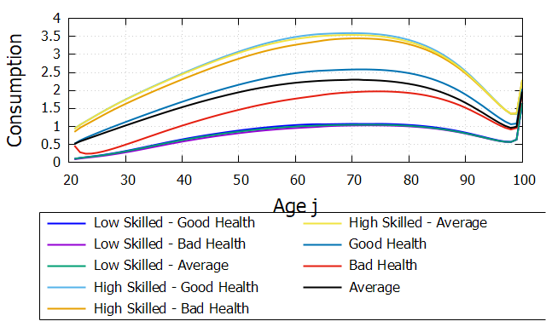 | 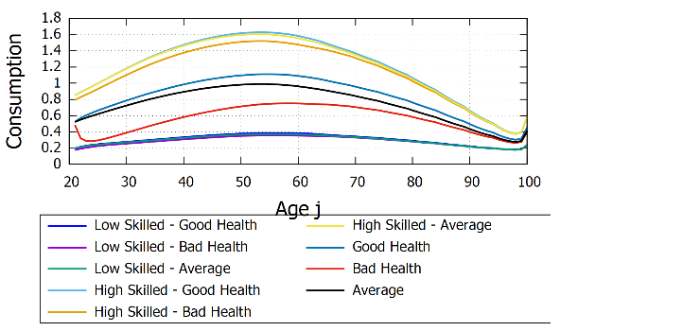
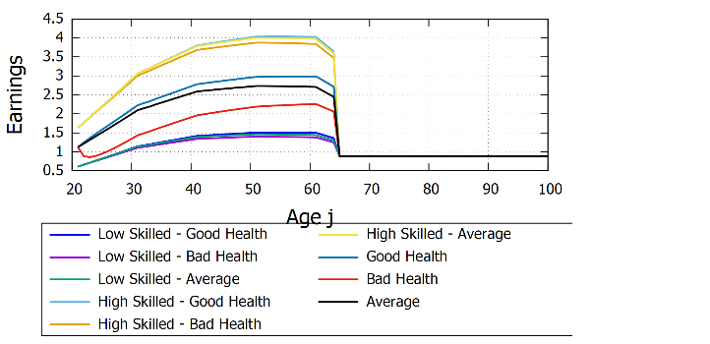 | 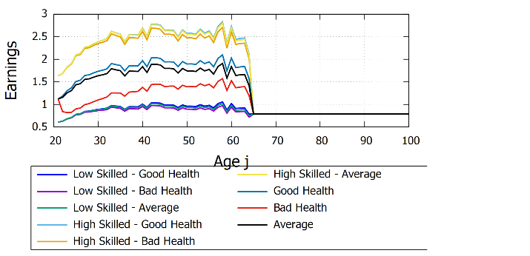

Reference Model | Mexico
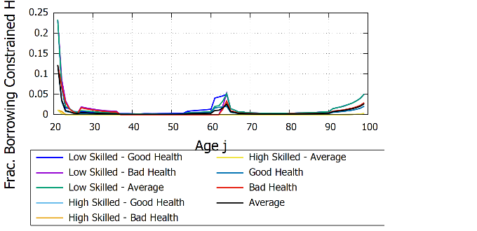 | 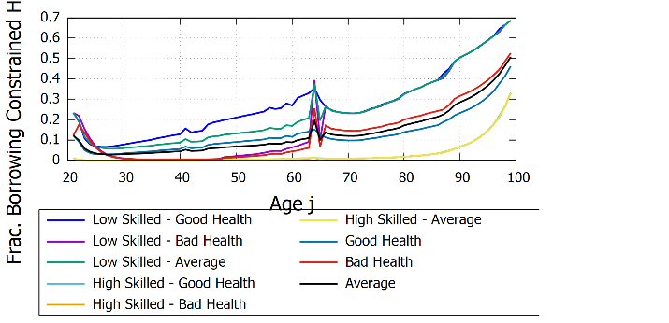

Average Consumption Over the Life Cycle
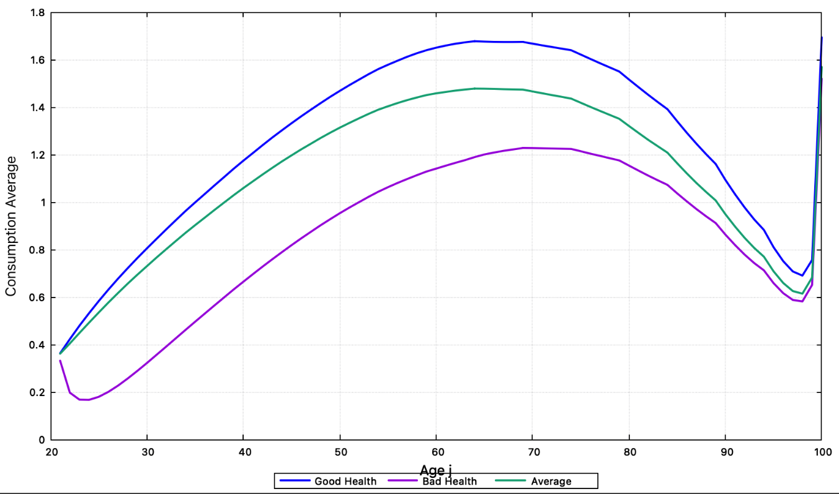
The average consumption profile (averaging over health states) reveals the classic life-cycle pattern with important deviations:
Accumulation phase (ages 20-45): Consumption grows from 0.36 to 1.48, representing a 311% increase over 25 years, or approximately 3.4% annual growth. This reflects rising labor productivity with experience and asset accumulation.
Retirement plateau (ages 45-70): Consumption remains remarkably stable between 1.43-1.47, declining by only 1.3% over 25 years. This near-flat profile is maintained through a combination of pension income, asset decumulation, and government transfers. The model successfully replicates the empirical regularity of consumption smoothing in retirement.
Late-life decline (ages 70-95): Consumption falls from 1.43 to 0.66, representing a 54% decline. This reflects: (a) depletion of assets, (b) rising out-of-pocket health costs not covered by insurance, and (c) health deterioration reducing utility from consumption. The sharp drop highlights the vulnerability of the elderly to health shocks.
Consumption by health status reveals persistent inequality:
- Age 30: good health = 0.845, bad health = 0.357 → gap of 57.8%
- Age 50: good health = 1.492, bad health = 0.824 → gap of 44.8%
- Age 70: good health = 1.660, bad health = 1.458 → gap of 12.2%
The narrowing gap at older ages (from 58% at age 30 to 12% at age 70) reflects the protective effect of government transfers and pensions that provide a consumption floor in retirement, compressing the distribution between healthy and sick individuals.

Evolution of Health Status Across the Life Cycle

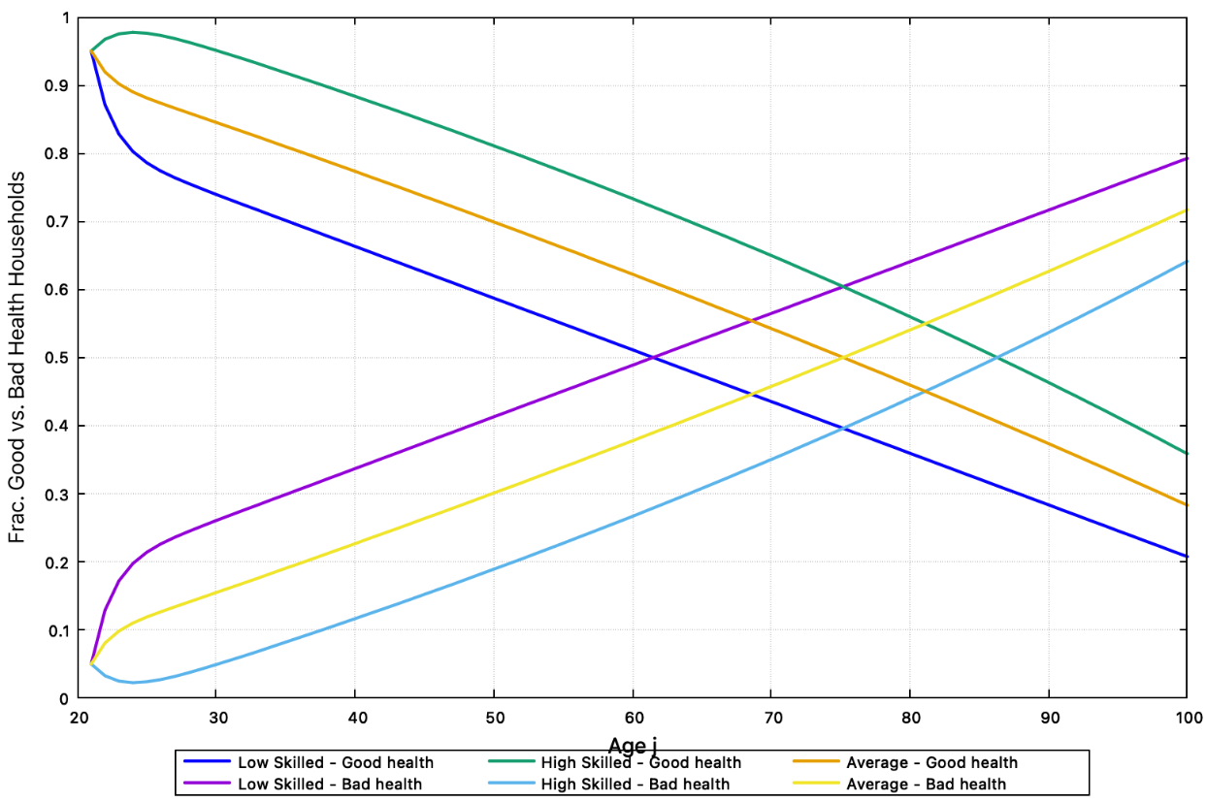

The health composition of the population evolves dramatically with age, reflecting both biological aging and cumulative effects of socioeconomic conditions. For low-skilled workers (blue and purple lines):
- At age 20: 95% in good health, 5% in bad health
- At age 40: 65% in good health, 35% in bad health
- At age 60: 50% in good health, 50% in bad health (crossing point)
- At age 80: 30% in good health, 70% in bad health
The rate of health deterioration averages approximately 1% per year between ages 20-60, accelerating thereafter. By age 60, half of all low-skilled workers are in poor health.
For high-skilled workers (green and light blue lines), the trajectory is markedly different:
- At age 40: 85% in good health, 15% in bad health
- At age 60: 70% in good health, 30% in bad health
- At age 80: 50% in good health, 50% in bad health (crossing point occurs 20 years later)
This 20-year advantage in healthy longevity for high-skilled workers represents a fundamental source of cumulative inequality. The policy implication is clear: interventions targeting low-skilled populations must begin in middle age (40-50 years) rather than waiting until elderly years when health deterioration has already advanced substantially.

Financial Vulnerability and Borrowing Constraints
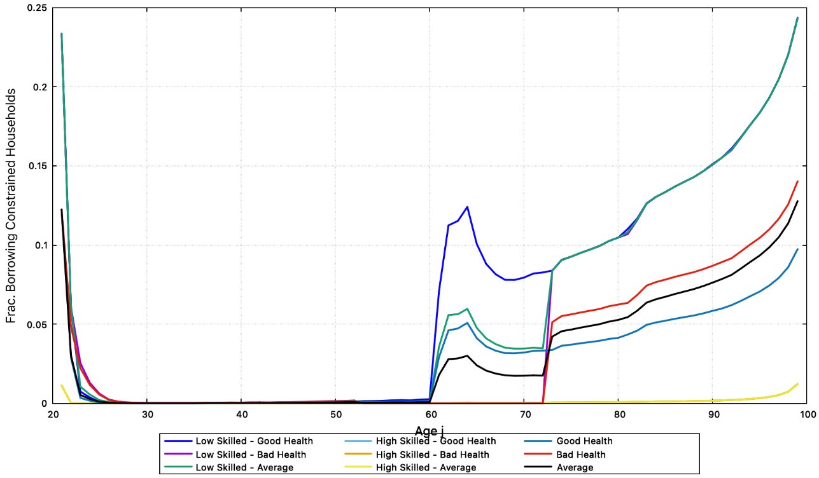

The fraction of households reaching the borrowing constraint (zero assets) reveals extreme financial vulnerability. For low-skilled workers with bad health (purple line):
- At age 20: 23% start life with no assets
- Ages 30-50: drops to near 0% (temporary accumulation period)
- At age 60: 12% hit the constraint again
- By age 100: 24% end life with zero assets
This U-shaped pattern indicates high vulnerability at life's beginning and end, with a brief window of relative security during prime working years. The resurgence of the constraint after age 60 coincides with rising health costs and declining income.
In stark contrast, high-skilled workers with bad health (yellow line) rarely exhaust their assets:
- Less than 1% hit the borrowing constraint at any age
- Even when experiencing poor health, higher lifetime earnings provide a protective buffer
The average population (black line) shows:
- Age 20: 12% begin with no assets
- Ages 30-60: less than 5% are constrained
- Age 90: 9% of survivors have zero assets
Policy interpretation: Approximately 1 in 8-10 low-skilled workers will require substantial government support during health crises in early retirement (ages 60-70). The 12% figure at age 60 represents a significant fiscal burden as the population ages.

Welfare losses from poor health
The value function (representing lifetime utility) quantifies welfare losses:
- Age 20: value with good health = -139.77, with bad health = -143.04 → loss of 2.3%
- Age 30: value with good health = -98.87, with bad health = -175.77 → loss of 77.8%
- Age 45: value with good health = -40.93, with bad health = -57.30 → loss of 40.0%
- Age 60: value with good health = -25.05, with bad health = -33.26 → loss of 32.8%
The 78% welfare loss experienced by a 30-year-old worker who develops poor health is staggering. This represents not merely reduced consumption but the combined effect of: (a) lower current consumption, (b) reduced future earnings, (c) higher future health costs, (d) lower utility from consumption when sick, and (e) reduced life expectancy.
These welfare calculations justify substantial public investment in health promotion and disease prevention, particularly targeting populations in their 30s and 40s when interventions can prevent decades of diminished welfare.
In summary, the quantitative results demonstrate that health effects on economic outcomes are not marginal but transformational. Consumption gaps of 40-70% between healthy and sick individuals during working years, welfare losses approaching 80% at age 30, and the crossing point at age 60 where half the population transitions to poor health constitute a public health and economic crisis that demands urgent policy attention. The vulnerability of individuals with poor health—with 12% hitting zero assets at age 60, consumption levels 40-60% below their healthy counterparts in prime working years, and income losses equivalent to 7.5 years of full salary over a career—indicates that current social safety nets may be insufficient to prevent widespread economic hardship as Mexico's population ages. The concentration of these effects at younger ages (peak welfare losses at 30, largest consumption gaps at 25) underscores the urgency of early intervention and prevention strategies.

Discussion
4.1 Health as a Macroeconomic State Variable
The results of this analysis, based on a dynamic and stochastic overlapping-generations model in partial equilibrium, highlight the central role of population health in shaping macroeconomic outcomes over the life cycle. Poor health conditions reduce labor productivity, depress income trajectories, and generate persistent consumption gaps between healthy and unhealthy individuals. These effects materialize not only at older ages — as standard life-cycle models would predict — but significantly earlier, altering saving behavior, increasing household indebtedness, and raising concerns about long-term fiscal and intergenerational sustainability. The model demonstrates that health status functions as a macroeconomic state variable with consequences comparable in magnitude to skill heterogeneity, challenging the traditional treatment of health as a sectoral concern separate from core macroeconomic dynamics.
4.2 The Compounding Mechanism
A key insight of the model is that health operates as a compounding mechanism across the life cycle. Through its simultaneous effects on utility, survival probabilities, labor productivity, and out-of-pocket expenditures, poor health weakens households' earning capacity while increasing their expenditure needs. This dual channel generates a reinforcing cycle: lower income reduces the capacity to invest in health and accumulate precautionary savings, while deteriorating health further depresses productivity and raises medical costs. As a result, individuals in poor health face substantially lower lifetime consumption and asset accumulation, even when government transfers provide a minimum consumption floor. The divergence in consumption paths between individuals in good and poor health is particularly pronounced among lower-skilled households, where the productivity penalty from poor health is larger and the capacity to self-insure through savings is more limited.
4.3 Early-Life Income Stagnation: The Mexico Case
The Mexican calibration illustrates these dynamics with particular clarity. Unlike the reference model, in which income continues to rise until middle age, the simulations calibrated for Mexico show that income levels stagnate around age 30. This stagnation coincides precisely with the age at which health-related expenditure needs begin to increase relative to income — a timing that has profound consequences for household financial resilience. Consequently, households begin relying on borrowing or transfers much earlier in the life cycle to smooth consumption in the presence of health shocks. This early onset of financial stress contrasts sharply with standard life-cycle predictions, where health-related borrowing typically emerges closer to retirement age. The finding suggests that in middle-income economies, the interaction between health expenditure timing and income dynamics creates vulnerabilities that models calibrated to high-income contexts do not capture.
4.4 Institutional and Epidemiological Context
These results acquire additional force when situated within Mexico's institutional and epidemiological context. The country combines persistently low public health expenditure — 626 USD PPP per capita, half the regional average — with one of the highest chronic disease burdens in Latin America. Diabetes alone affects 16.9% of the population, disproportionately impacting working-age adults whose productivity losses cascade through household income and savings. The model suggests that insufficient health investment today does not merely translate into higher medical costs at older ages; it actively undermines productivity and income generation during prime working years. This weakens households' ability to self-insure through savings and increases reliance on out-of-pocket spending and public transfers — precisely the channels through which fiscal stress accumulates. The partial equilibrium framework adopted here isolates these household-level mechanisms with clarity, though a general equilibrium extension would capture additional feedback through wages and interest rates.
4.5 Intergenerational Trade-offs
From an intergenerational perspective, the findings point to an important trade-off embedded in fiscal allocation decisions. As health-related needs among adults and the elderly grow, greater fiscal resources are required to prevent sharp declines in consumption and welfare among affected cohorts. However, if these resources are mobilized without expanding overall fiscal space — a binding constraint in most middle-income economies — they may crowd out investment in the health and human capital of younger cohorts. Such dynamics risk perpetuating a cycle in which poor health outcomes today reduce productivity and fiscal capacity tomorrow, constraining future investment and growth. The 78% welfare loss experienced by a 30-year-old worker who develops poor health quantifies the magnitude of this intergenerational transmission: today's health failures become tomorrow's fiscal burdens.
4.6 Health Investment as Fiscal Strategy
The analysis underscores that health should not be viewed solely as a sectoral expenditure item but as a core determinant of macroeconomic stability and intergenerational equity. In contexts like Mexico, where demographic aging interacts with low public health spending and high out-of-pocket exposure, neglecting the macroeconomic role of health amplifies fiscal vulnerabilities and deepens inequality over the life cycle. The consumption gaps of 40–70% documented in this paper are not residual effects but first-order macroeconomic distortions with implications for aggregate demand, savings rates, and the distribution of welfare across cohorts. Strengthening health investment and reducing households' exposure to health-related financial risk emerge not as social policy aspirations but as central components of a sustainable long-term fiscal strategy — a conclusion reinforced by the early-life timing of income stagnation documented in the Mexico calibration.
4.7 Demographic Transition and Fiscal Imbalance
Beyond household-level dynamics, the results speak directly to the interaction between fiscal sustainability and the demographic transition — the central analytical challenge for economies aging before reaching high-income status. Population aging alters the age composition of health expenditure toward older cohorts, while declining fertility — Mexico's TFR of 1.55 now sits below replacement and below the United States — limits the growth of the contribution base and future labor income. In this context, health-related shocks that depress productivity and income at earlier ages amplify fiscal pressures through multiple channels simultaneously: lower tax bases from reduced labor productivity, higher demand for transfers as households exhaust savings earlier, and rising health-related public and private expenditures as chronic disease prevalence increases with population aging. The model highlights that fiscal stress associated with aging is not confined to pension systems alone; health conditions act as an additional — and often underestimated — driver of long-run fiscal imbalance. For economies like Mexico, where the narrowing contribution base coincides with the income stagnation documented at age 30, the fiscal arithmetic of demographic transition is more adverse than pension-focused analyses suggest. Ignoring the macroeconomic consequences of population health understates the true fiscal cost of demographic transition and risks policy responses that arrive too late or target too narrow a set of fiscal channels.
Finally, the analysis is closely connected to the empirical evidence presented in the Appendix, which documents the evolving burden of disease in Costa Rica, Mexico, and Panama using Global Burden of Disease (GBD) data. The dominance and persistence of chronic noncommunicable diseases—such as diabetes, cardiovascular disease, and chronic kidney disease—provide a concrete epidemiological foundation for the health shocks modeled in this paper. The Appendix illustrates that these conditions are not temporary phenomena but structural features of the region’s health profile, reinforcing the relevance of modeling health as a persistent state affecting productivity, survival, and expenditures over the life cycle. In this sense, the Appendix complements the core analysis by grounding the theoretical results in observed epidemiological trends and by motivating future extensions that explicitly integrate disease-specific dynamics, cross-country comparisons, and policy interventions into the modeling framework.

References
CIEP. (2018). Sistema Universal de Salud: retos de cobertura y financiamiento. Obtenido de https://saludenmexico.ciep.mx/
CONAPO. (2023). Bases de datos de la Conciliación Demográfica 1950 a 2019 y Proyecciones de la población de México 2020 a 2070. Obtenido de https://www.gob.mx/conapo/documentos/bases-de-datos-de-la-conciliacion-demografica-1950-a-2019-y-proyecciones-de-la-poblacion-de-mexico-2020-a-2070
Dalgaard, Carl-Johan, and Holger Strulik (2014). “Optimal Aging and Death: Understanding the Preston Curve.” Journal of the European Economic Association, 12(3), 672–701. https://doi.org/10.1111/jeea.12062
De Nardi, M., French, E., & Jones, J. (2010). Why do the elderly save? The role of medical expenses. Journal of political economy.
DGIS, S. (2022). Subsistema de Cuentas en Salud (SICUENTAS). Obtenido de https://sinba.salud.gob.mx/SICUENTAS
Dougherty, S., Lorenzoni, L., & Pisu, P. (2022). Funding the future: The impact of population ageing on revenues across levels of government. OECD Working Papers on Fiscal Federalism, No.39.
Fehr, H., & Kindermann, F. (2018). Introduction to Computational Economics using Fortran. Oxford University Press.
Fioroni, T. (2010), “Optimal savings and health spending over the life cycle.”, European Journal of Health Economics, 10.1007/S10198-009-0183-0
Franković, Ivan and Stefan Wrzaczek (2020). “On the Anatomy of Medical Progress within an Overlapping Generations Economy.” Journal of Economics (Springer), 129(1), 65–97. https://doi.org/10.1007/s10645-020-09360-3
Haakenstad, A., Bintz, C., Knight, M., Bienhoff, K., Chacon-Torrico, H., Curioso, W., . . . Hay, S. (2023). Catastrophic health expenditure during the COVID-19 pandemic in five countries: a time series analysis. Lancet Global Health. Obtenido de https://www.thelancet.com/journals/langlo/article/PIIS2214-109X(23)00330-3/fulltext
IMF. (2016). Fiscal Policy. How to Asses Fiscal Implications of Demographic Shifts: A granular approach. En Fiscal Affair Department. How to- Notes.
INEGI. (2015). ENOE. Obtenido de https://www.inegi.org.mx/programas/enoe/15ymas/
Kuhn, Michael and Gustav Feichtinger (2015). “Optimal Choice of Health and Retirement in a Life-Cycle Model.” Journal of Economic Theory, 158, 186–212. https://doi.org/10.1016/j.jet.2015.03.010
Lim, Kyoung Mook (2020). “Public Provision of Health Insurance and Aggregate Saving in an Overlapping Generations Model with Endogenous Health Risk: The South Korean Case.” Economic Modelling, 90, 208–221. https://doi.org/10.1016/j.econmod.2020.05.023
Méndez Méndez, J. (octubre de 2019). La contracción del gasto per cápita en salud: 2010 – 2020. Obtenido de https://ciep.mx/la-contraccion-del-gasto-per-capita-en-salud-2010-2020/
OCDE. (07 de noviembre de 2023). Health at a Glance 2023. Obtenido de https://www.oecd.org/health/health-at-a-glance/
OPS, O. (15 de 05 de 2024). Curso de vida saludable. Obtenido de https://www.paho.org/es/temas/curso-vida-saludable
SSa, INSP, UISP. (2019). Unidad de Inteligencia en Salud Pública. Obtenido de https://uisp.insp.mx/wp/index.php/tablas-de-vida/
Yew, Siew Ling and Jie Zhang (2018). “Health Spending, Savings and Fertility in a Lifecycle-Dynastic Model with Longevity Externalities.” Journal of Population Economics, 31(4), 1209–1246. https://doi.org/10.1007/s00148-018-0697-6

Appendix
The following appendix documents the evolving burden of disease in three Latin American countries using Global Burden of Disease (GBD) data. Costa Rica, Mexico, and Panama bracket the region's epidemiological transition: Costa Rica represents an advanced transition with relatively high public health spending; Mexico occupies a middle position with low public spending and exceptionally high diabetes prevalence; and Panama represents an intermediate case. Together, these three profiles illustrate the structural persistence of chronic noncommunicable diseases across the region and strengthen the generalizability of the health dynamics modeled in this paper.
GBD: Costa Rica
Disability-Adjusted Life Years (DALYs) provide a comprehensive metric for measuring the burden of disease by combining premature mortality and disability. Based on Global Burden of Disease (GBD) estimates, this analysis presents the evolution of DALYs in Costa Rica between 2015 and 2023, with the aim of identifying trends, relevant changes, and the major health problems that shaped this period.
2015
In 2015, the disease burden in Costa Rica was dominated by chronic illnesses, particularly cardiovascular diseases such as stroke and ischemic heart disease, along with diabetes and chronic kidney disease. Musculoskeletal disorders and mental health conditions also held considerable weight within the DALYs. Among communicable diseases, neonatal disorders, respiratory infections, and HIV remained relevant, although to a lesser extent than chronic conditions. Injuries continued to play a significant role, especially traffic accidents, violence, and self-harm.
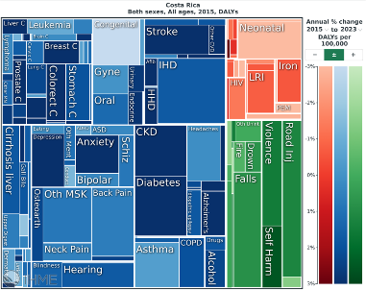
2023
In 2023, Costa Rica continued to display a disease burden profile clearly dominated by chronic conditions, especially ischemic heart disease, diabetes, and chronic kidney disease, which ranked among the top causes of DALYs. Musculoskeletal and mental health disorders maintained a significant presence, while COVID-19 continued to be relevant among communicable diseases, albeit with less weight than in previous years. Neonatal problems and respiratory infections remained among the leading communicable causes. Injuries sustained their usual contribution, with falls, traffic accidents, and violence standing out.
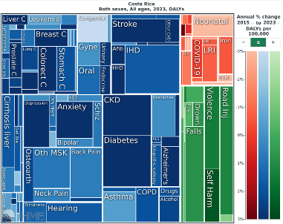
Between 2015 and 2023, Costa Rica exhibits a clear trend toward the increasing predominance of chronic diseases, with ischemic heart disease, diabetes, and chronic kidney disease consolidating themselves among the top-ranked causes. Musculoskeletal and mental health conditions have risen slightly in importance, reflecting their sustained weight in the burden of morbidity. Communicable diseases—such as neonatal disorders and respiratory infections—have gradually declined and lost relative prominence, except for the temporary disruption caused by COVID-19. Injuries—particularly falls, traffic accidents, and violence—remained stable throughout the period. Overall, the data reveal a consistent process of epidemiological transition, with the disease burden increasingly concentrated in noncommunicable conditions.
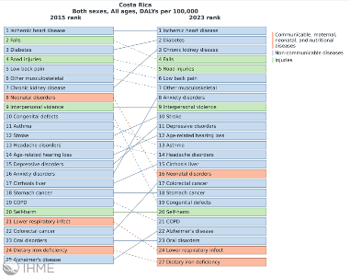

GBD: Mexico
Disability-Adjusted Life Years (DALYs) provide a comprehensive measure of the burden of disease by combining premature mortality and disability. Based on Global Burden of Disease (GBD) estimates, this analysis presents the evolution of DALYs in Mexico between 2015 and 2023, with the goal of identifying trends, relevant changes, and the main health problems that have shaped this period.
2015
In 2015, Mexico’s disease burden was dominated by chronic and noncommunicable conditions, with a notable weight of diabetes, cardiovascular diseases, chronic kidney disease, congenital disorders, and various neuropsychiatric and musculoskeletal conditions. Communicable, maternal, and child-related causes continued to represent a relevant share, as did injuries, particularly unintentional injuries, suicide, interpersonal violence, and transport accidents. Overall, the profile reflects a country in epidemiological transition, with chronic diseases predominating yet still accompanied by a considerable burden from preventable causes.
2023
By 2023, the burden associated with COVID-19 decreased even further, remaining visible but no longer dominant due to sustained reductions in mortality. The profile once again resembled the pre-pandemic pattern, where chronic diseases—diabetes, chronic kidney disease, ischemic heart disease, and cerebrovascular disease—returned to the center of DALY contributions. Mental and musculoskeletal disorders continued to be significant due to their contribution to disability, while neonatal conditions and lower respiratory infections maintained their relative weight. Injuries, particularly traffic accidents and violence, remained constant components of the disease burden. Thus, 2023 reflects a post-pandemic realignment and a return to long-term structural trends.
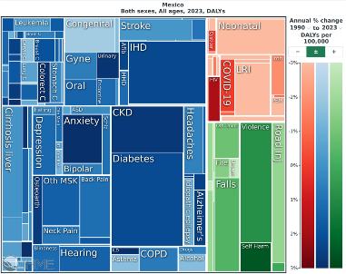
Between 2015 and 2023, Mexico’s disease burden was dominated by chronic conditions, along with a constant contribution from mental, musculoskeletal, and neonatal disorders. Injuries—especially traffic accidents, suicide, and violence—remained relevant causes throughout the entire period. This stable pattern was disrupted in 2020 with the emergence of COVID-19, which became one of the main sources of DALYs and temporarily altered the epidemiological profile. Although its magnitude diminished progressively in 2021–2023, the pandemic left a visible impact before the landscape returned to a structure similar to that observed in preceding years.
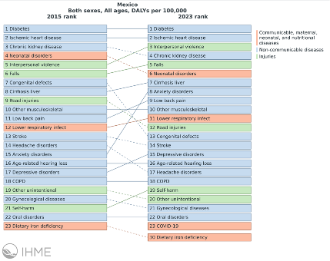
GBD: Panama
Disability-Adjusted Life Years (DALYs) provide a comprehensive measure of the burden of disease by combining premature mortality and disability. Based on Global Burden of Disease (GBD) estimates, this analysis presents the evolution of DALYs in Panama between 2015 and 2023, with the aim of identifying trends, relevant changes, and the major health problems that have characterized this period.
2015
In 2015, Panama’s disease burden was dominated by chronic conditions, particularly cardiovascular diseases, diabetes, and chronic kidney disease. Musculoskeletal disorders and mental health conditions also contributed a considerable share of DALYs. Among communicable diseases, neonatal disorders, respiratory infections, and diarrhea stood out, while HIV drew attention due to its high burden and unfavorable trend. Injuries—especially traffic accidents—remained significant, along with falls, violence, and self-harm.

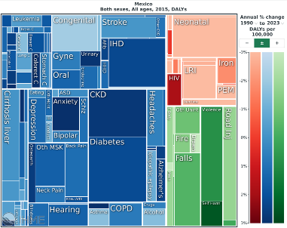
2023
In 2023, chronic diseases continued to dominate Panama’s burden of disease, with ischemic heart disease, diabetes, and chronic kidney disease among the leading causes of DALYs. Stroke also remained highly relevant. Among communicable causes, COVID-19 remained present though less prominent, accompanied by neonatal disorders, respiratory infections, and HIV. Musculoskeletal and mental health problems remained stable, and injuries retained their usual pattern, with traffic accidents, falls, and violence standing out.
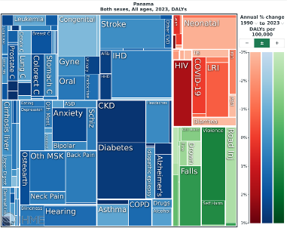
The comparison between 2015 and 2023 shows a clear strengthening of chronic diseases, which climb the ranking and displace several communicable conditions. Neonatal disorders remain relevant but lose position to the rise of noncommunicable diseases (NCDs). Injuries remain relatively stable over time, without marked variations. HIV declines slightly in importance, while COVID-19 emerges as a disruptive event in recent years. Overall, the data reflects a consolidated epidemiological transition, characterized by the growing predominance of noncommunicable diseases.
